1 ASIX

**MÒDUL 5: FONAMENTS DE MAQUINARI**

ACTIVITAT 3: La BIOS

línea horizontal

# 

**Alumne**: Daniel Mascarilla del Olmo

**Professor**: Jacinto López

**Curs**: 1 ASIX

**Centre**: Jaume Viladoms

**ÍNDEX**

**Exercise 1: Look for information on Internet about BIOS** **3**

What’s ROM memory? 3

ROM types. 3

What’s FLASHBIOS? 3

Manufactures BIOS? 3

BIOS functions. 3

What’s Shadowing? 4

What’s CMOS? 4

Differences between BIOS and CMOS? 4

Post and Boot Process 4

Explain a BIOS model, specifying the configuration screens. 5

HOW TO ENTER THE BIOS 6

MAIN SCREEN 8

ADVANCED SCREEN 10

SECURITY SCREEN 11

BOOT SCREEN 12

EXIT SCREEN 13

# 

# Exercise 1: Look for information on Internet about BIOS

## What’s ROM memory?

ROM memory ( or Read-only memory ) is a type of non-volatile memory which is used in computers and other electronic devices. The data which is inside the ROM can’t be modified electronically after the manufacture of the memory device. This memory is used to store software which is rarely changed during the life of the system ( firmware ).

## ROM types.

* ROM memory.
* PROM memory.
* EPROM memory.
* EPROM Flash Memory.
* NAND Flash memory.

## What’s FLASHBIOS?

The FLASHBIOS is refered to the BIOS chips that can be reprogrammed with special software without needing to be replaced.

## Manufactures BIOS?

For example:

* Phoenix Technologies
* IBM
* Dell
* BYOSOFT
* AMI ( American Megatrends )
* Insyde Software

## BIOS functions.

The BIOS has 4 functions:

* Identifies computer hardware
* Configures computer hardware
* Tests computer hardware
* Connects computer hardware to the OS

The combination of these 4 functions is what we call the Boot process, which I’ll explain later on.

## What’s Shadowing?

Shadowing is a strategy that consists of figuratively becoming a user's shadow for a specific period of time in order to follow their activity and understand both what they do and what leads them to do it.

## What’s CMOS?

The CMOS’s a small amount of memory on a computer motherboard that stores the Basic Input/Output System (BIOS) settings. The BIOS is the software stored in the memory chip on the motherboard.

## Differences between BIOS and CMOS?

The main difference is that CMOS is shown more as hardware and BIOS as software. The function of the former is to store BIOS settings and retain them.

In contrast, the latter is software that is used to initialize the PC, such as making settings on the system. In other words, the BIOS relies on the CMOS to store settings. Therefore, the CMOS is subordinate to the BIOS.

## 

## 

## 

## Post and Boot Process

POST:

When the computer is first turned on, the BIOS must test and initialise all components, and the operating system must be loaded into memory. This is commonly referred to as POST (power-on self-test). The POST process can be divided into two categories related to the main computer hardware and to the configuration and hardware on the board that is not part of the system.

BOOT:

The boot process starts after the POST and ends when the operating system is loaded.

## Explain a BIOS model, specifying the configuration screens.

The BIOS model I’m explaining is one of the Asus, the manufacturer is Phoenix.

The reason why I’m choosing this BIOS instead of mine is because I don't know how to access my BIOS, because the model of the BIOS of my computer was released months ago, and I don't find any information about how to access that BIOS. The model of my BIOS is Reale 1.02

### HOW TO ENTER THE BIOS

In order to enter the bios, we have to configuration and windows update:

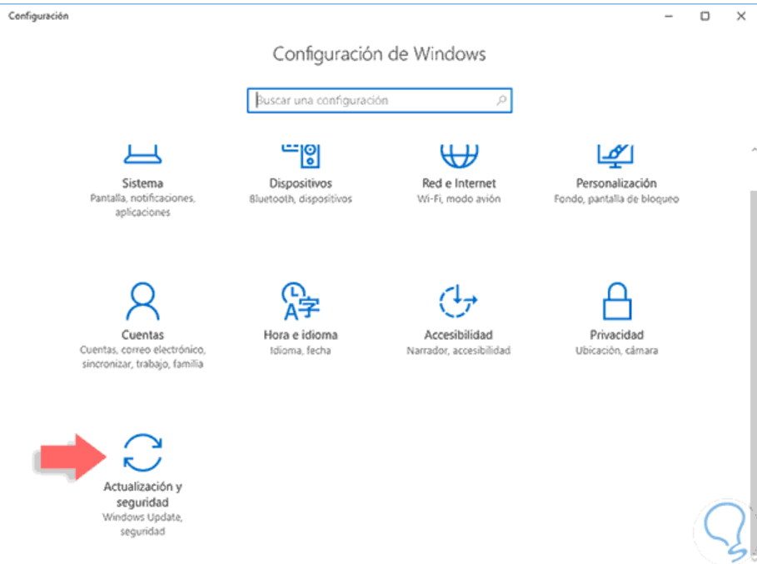

Next, we have to click in recover:

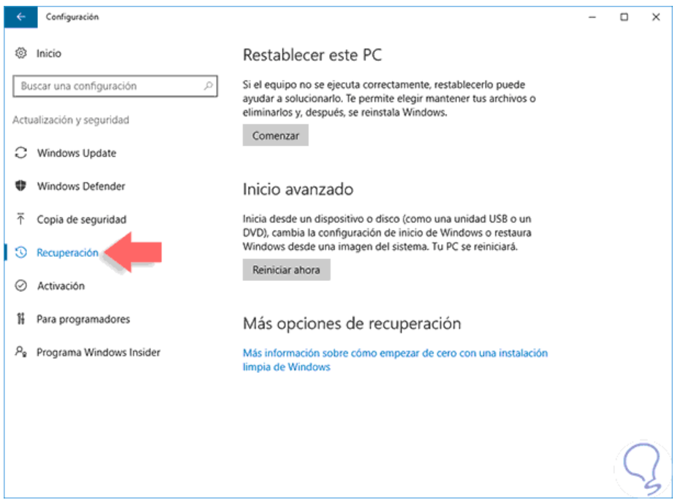

Next, we have to restart the system, and when the system is restarted, click the option “UEFI firmware settings”:

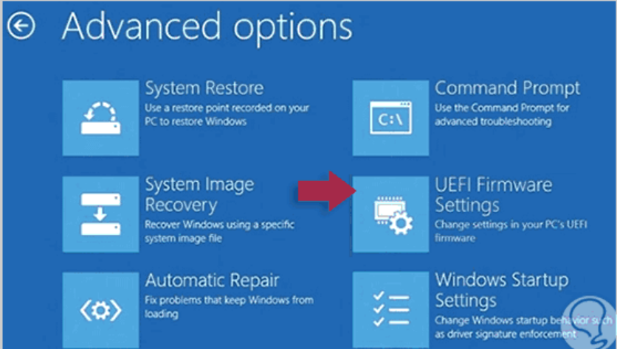

With this, we are inside the BIOS of the system.

### MAIN SCREEN

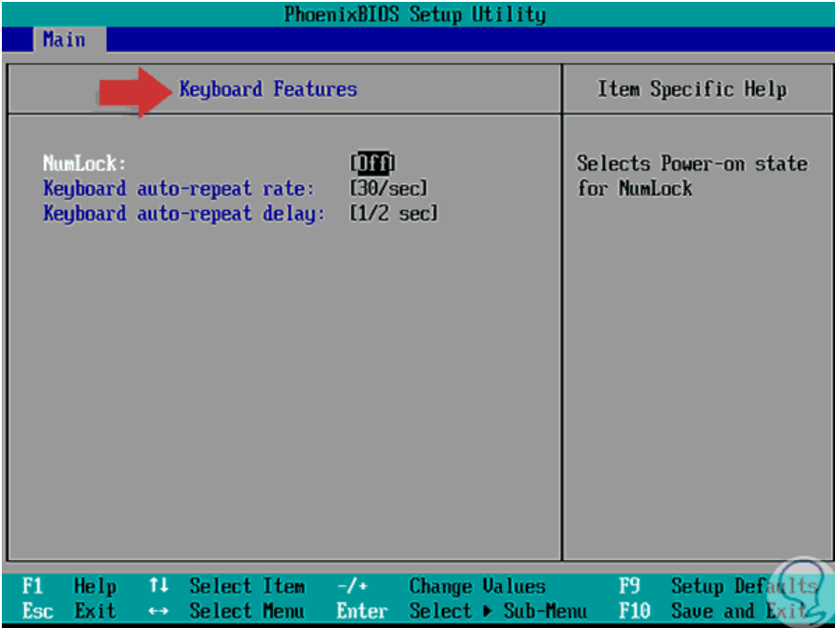

This is the Main screen, in this screen we can modify the data and hour of the system, enable or disable floppy disk drives, set which hard disk is to be master or slave, view information on components such as memory.

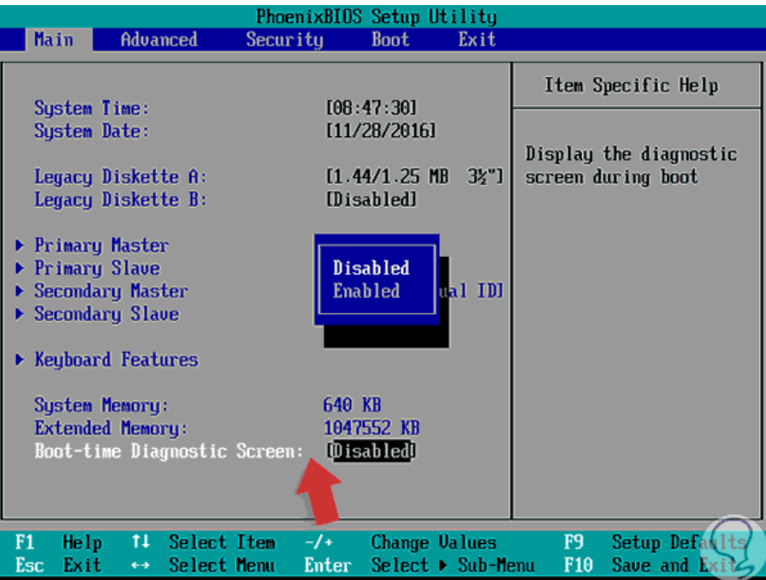

This is also part of the main screen, where we can modify other data.

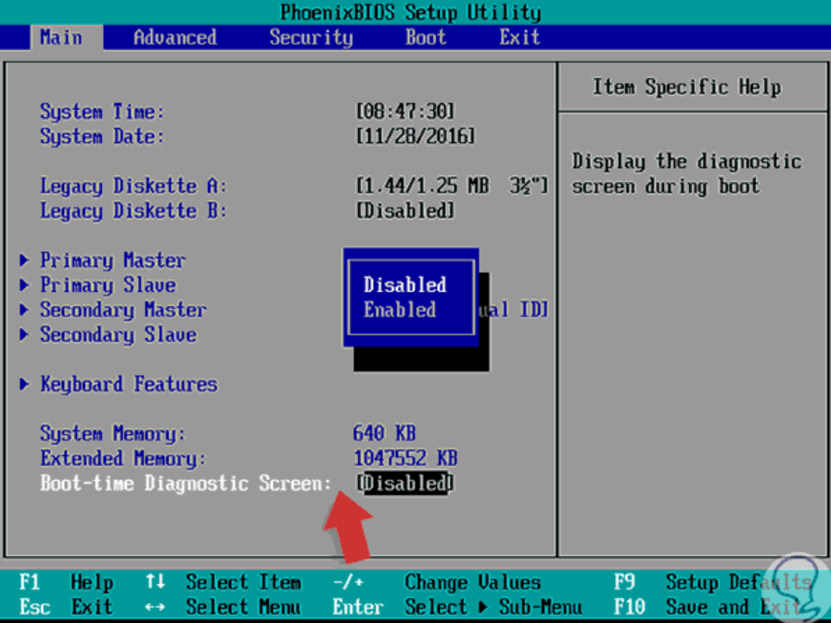

### 

### 

### 

### 

### 

### 

### 

### 

### 

### 

### 

### 

### 

### 

### 

### ADVANCED SCREEN

In this screen, we have access to different information about the BIOS, more specific information.

In this screen, we have access to:

* Operating System Information
* Processor Specifications
* We have the possibility to reset the date configuration.
* Configure input / output devices
* View advanced chipset configurations, among others.

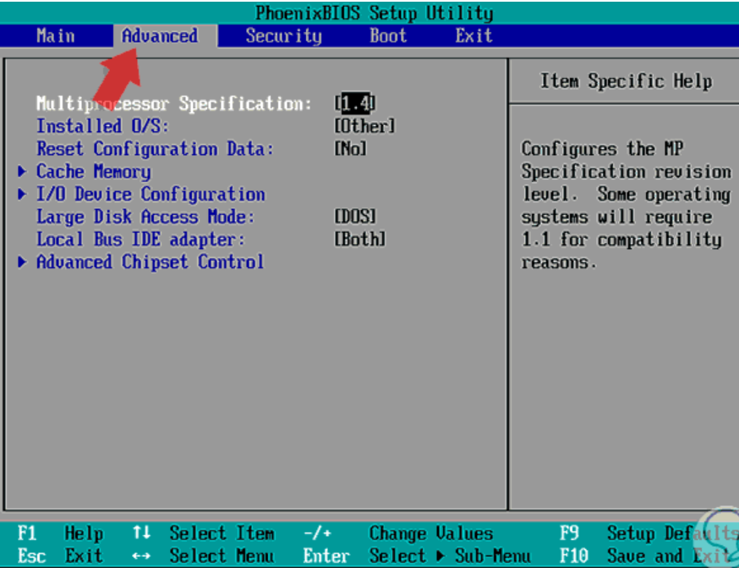

### 

### SECURITY SCREEN

In this screen,we can set security parameters for accessing and editing the BIOS values and therefore the system, since here we can set an access password which will be requested every time we try to access the BIOS.

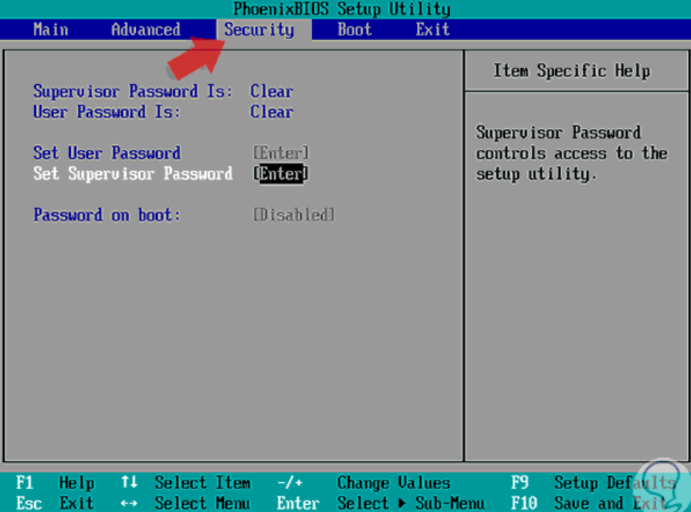

### 

### 

### 

### 

### 

### BOOT SCREEN

In this screen, we can define the boot order of the system, in case a reinstallation of the operating system is necessary and if we have a CD or DVD we must establish that the first boot device must be CD-ROM Drive or if we have a Bootable USB it will be necessary to establish Removable Devices as the initial boot device.

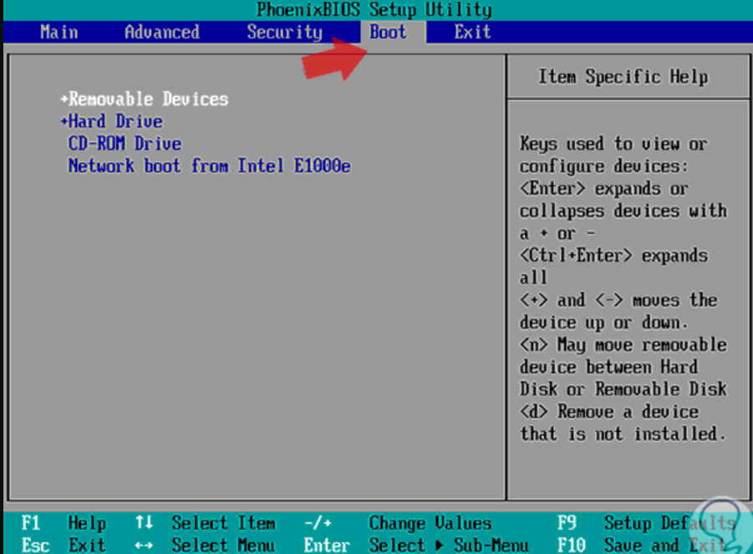

### 

### 

### 

### 

### 

### 

### 

### EXIT SCREEN

In this screen, we can exit the BIOS saving changes or not, and other options:

